About you | [Salutation] | Yale | [Middle name] | Halevi-Wise
About you | [Enter your biography]
About you | [Enter the institution with which you are affiliated]

Your article
Yehoshua, A.B.
[Enter any variant forms of your headword – OPTIONAL]
A leading Israeli writer and cultural figure since the 1960s, Avraham B. Yehoshua’s work was recognized even when he was a young man as representing a "new wave" in modern Hebrew literature. His absurd plots and obsessive protagonists signaled a break with the realist style and ideological collectivism characterizing the literature of a generation that had fought to establish the State of Israel in 1948.
A leading Israeli writer and cultural figure since the 1960s, Avraham B. Yehoshua’s work was recognized even when he was a young man as representing a "new wave" in modern Hebrew literature. His absurd plots and obsessive protagonists signaled a break with the realist style and ideological collectivism characterizing the literature of a generation that had fought to establish the State of Israel in 1948. By contrast, the "new wave" writers moved toward abstract modernism, identity fragmentation, and absurd plots which, in Yehoshua’s case, revolve around dysfunctional families and tensions between nations and generations.

His first novel, Ha-Meahev (1977, The Lover) surprised readers accustomed to his short stories as it moved away from an abstract surrealism to engage more directly with Israeli reality in the aftermath of the Yom Kippur War of 1973. The social and political engagement of his subsequent fiction is so strong that all of his novels can be called condition-of-Israel novels, even when they are set in historical rather than contemporary contexts, as in Masah el Tom Ha-Elef (1997, A Journey to the End of the Millennium), set in the Middle Ages, and Mar Mani (1990, Mr. Mani), a postmodern historical novel composed of five complex conversations going back in time to cover two hundred years of Jewish life around the Mediterranean basin.

Yehoshua's masterpiece, Mr. Mani, brought to the fore his Sephardic roots as a descendant of Ladino-speaking Jews who lived in Jerusalem and around the Mediterranean for many generations. Instead of using his ethnic identity to present a narrow social perspective, Yehoshua’s sephardism generates a social and religious panorama that includes Sephardic and Ashkenazi Jews as well as Muslims, Christians, and even pagans from different age groups and classes. This panoramic interface enables him to deal provocatively with moral and existential challenges to Israeli identity and survival in the past and in our current time.

As a public intellectual of considerable influence in Israel and abroad, Yehoshua’s preoccupation with what he calls the "diaspora neurosis" never fails to generate heated debates about Jewish identity. One such international debate became known as the “Yehoshua Controversy.” A frequent guest at cultural events in Israel, Europe, and America, his public outreach through lectures, editorials, and essay collections enriches our understanding of the ideological dimensions of his works.

Stylistically, A.B. Yehoshua is indebted primarily to Faulkner’s fragmentation of multiple points of view and to Agnon’s projection of historiosophic and intertextual references onto a modern plot. However, his brand of psychological realism also owes much to Dostoyevsky’s focus on what Yehoshua has called “the terrible power of a minor guilt.”

Translated into over twenty-eight languages, his novels and short stories have been adapted to film, television, theatre, and opera. A Jerusalem native who spent most of his professional life teaching and writing in Haifa, Yehoshua recently moved to Tel Aviv with his wife, the psychologist Dr. Rivka Yehoshua, to live near their children and grandchildren.

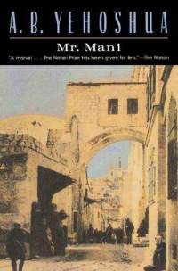
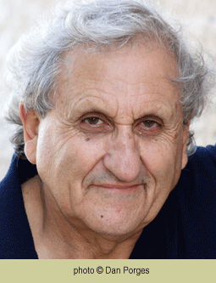
Further reading:
Ben-Dov, Nitza, ed. In the Opposite Direction: Articles on Mr. Mani [Hebrew]. Tel Aviv: HaKibbutz HaMeuhad, 1995.
Halevi-Wise, Yael. “A. B. Yehoshua’s Mr. Mani and the Playful Subjectivity of History,” in Interactive Fictions: Scenes of Storytelling in the Novel. Westport, CT & London: Praeger, 2003. 132-145.
Horn, Bernard. Facing the Fires: Conversations with A. B. Yehoshua. Syracuse, NY: Syracuse UP, 1997.
---. “Sephardic Identity and Its Discontents: The Novels of A. B. Yehoshua,” in Sephardism. Ed. Y. Halevi-Wise. Palo Alto, CA: Stanford UP, 2012. 189-210.
“Live Shorts,” A. B. Yehoshua in conversation with Paul Holdengräber: http://www.youtube.com/watch?v=-x6VHM4Zc4I
Morahg, Gilead. "Reality and Symbol in the Fiction of A. B. Yehoshua," Prooftexts 2.2 (1982): 179-196.
Shaked, Gershon. Modern Hebrew Fiction. Bloomington: Indiana UP, 2000.

